**INSTALLATION MANUAL FOR MAVEN**

**Installation and Setup**

1. Make sure you are connected to the internet.

2. Be certain that you have installed the latest JDK else, download it here: http://www.oracle.com/technetwork/java/javase/downloads/index.html

3. Download the latest version of maven here: <http://www-eu.apache.org/dist/maven/maven-3/3.5.0/binaries/apache-maven-3.5.0-bin.zip>

***-***

A. Setting up Java Environment Variables

1.2 Locate your java JDK (e.g. C:\Program Files\Java\jdk1.8.0_102) and copy its directory

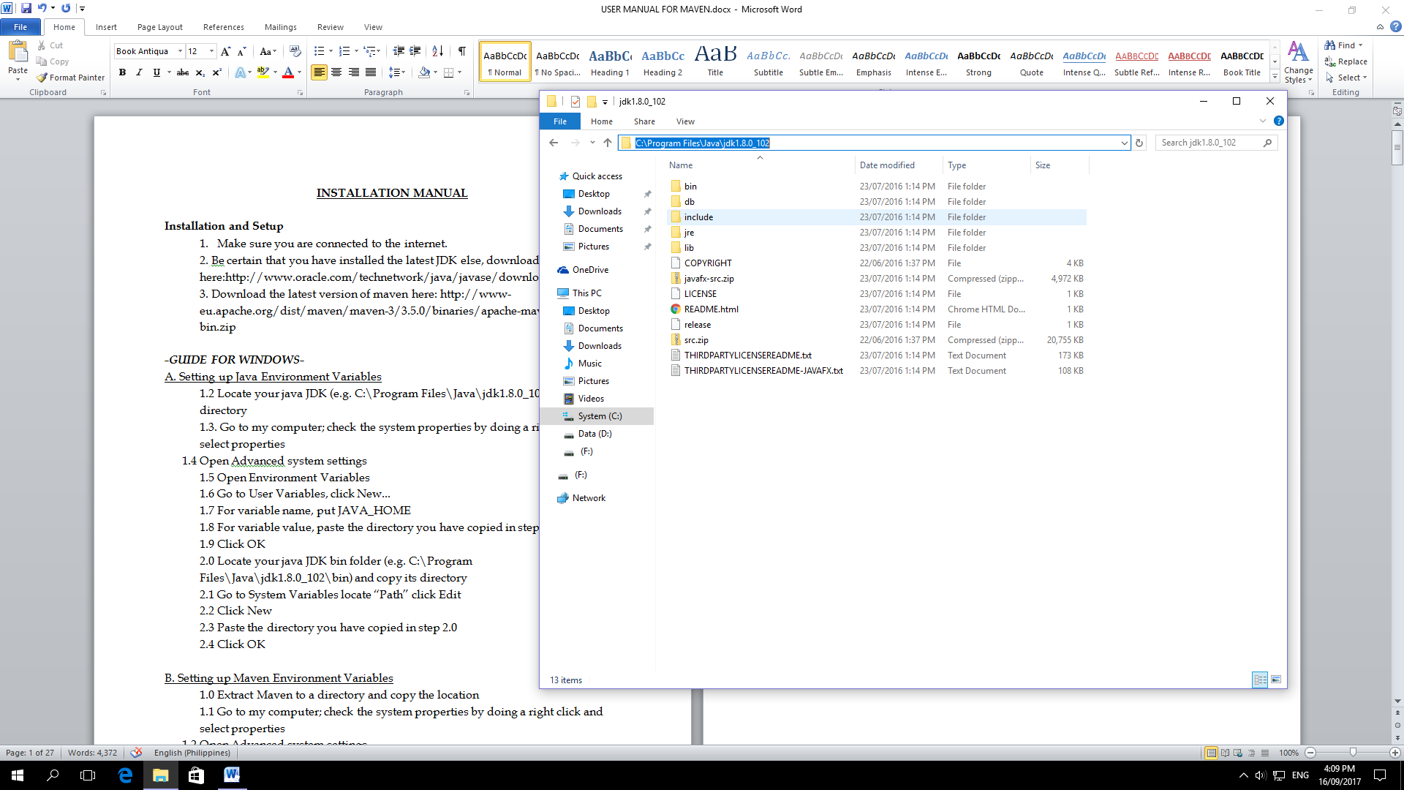

* 1. 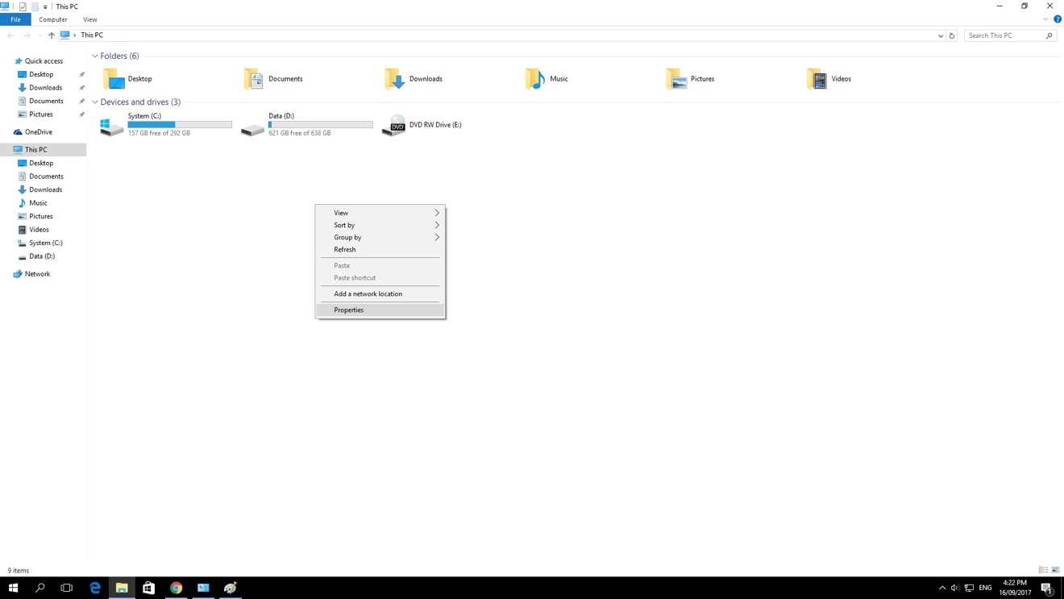Go to my computer; check the system properties by doing a right click and select properties

1.4 Open Advanced system settings

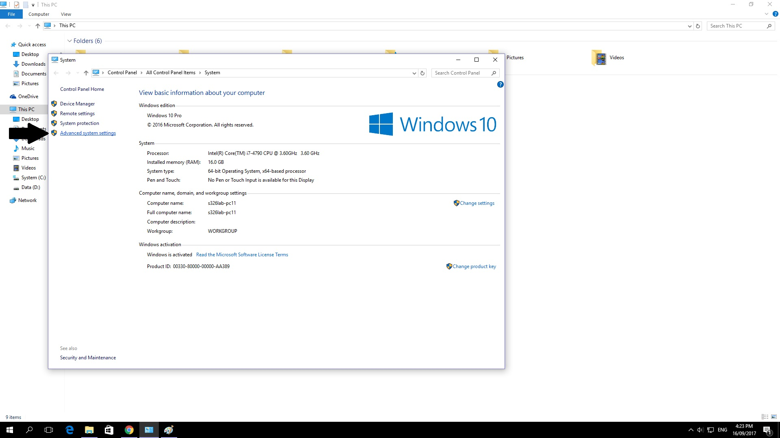

1.5 Open Environment Variables

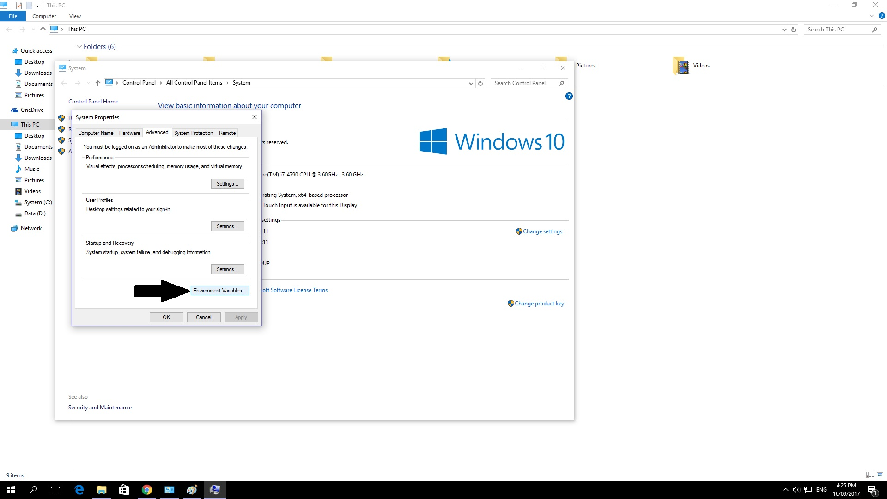

1.6 Go to User Variables, click New...

1.7 For variable name, put JAVA_HOME

1.8 For variable value, paste the directory you have copied in step 1

1.9 Click OK

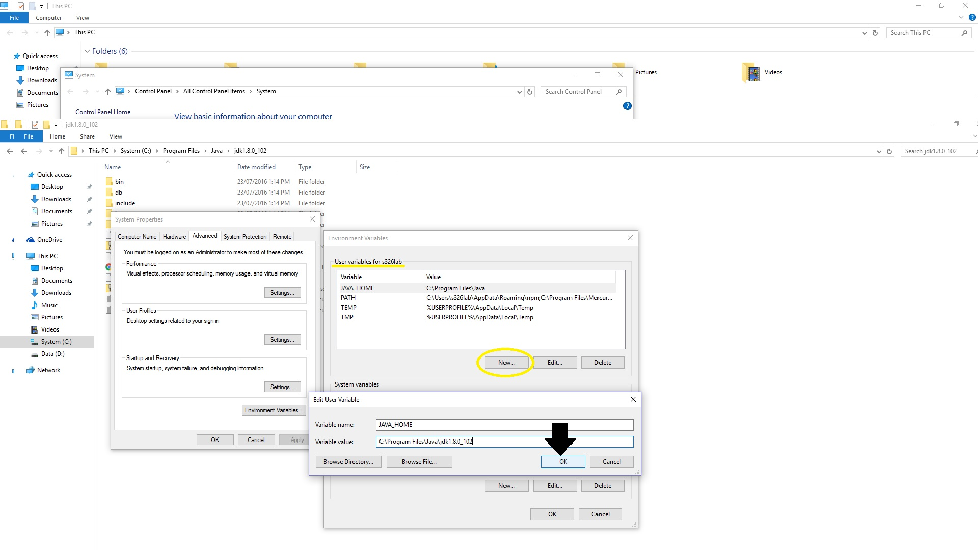

2.0 Locate your java JDK bin folder (e.g. C:\Program Files\Java\jdk1.8.0_102\bin) and copy its directory

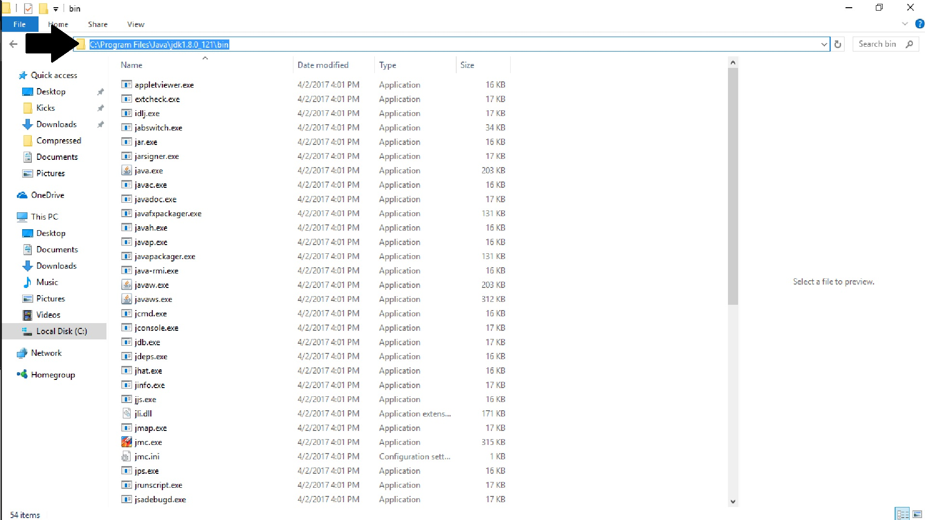

2.1 Go to System Variables locate “Path” click Edit

2.2 Click New

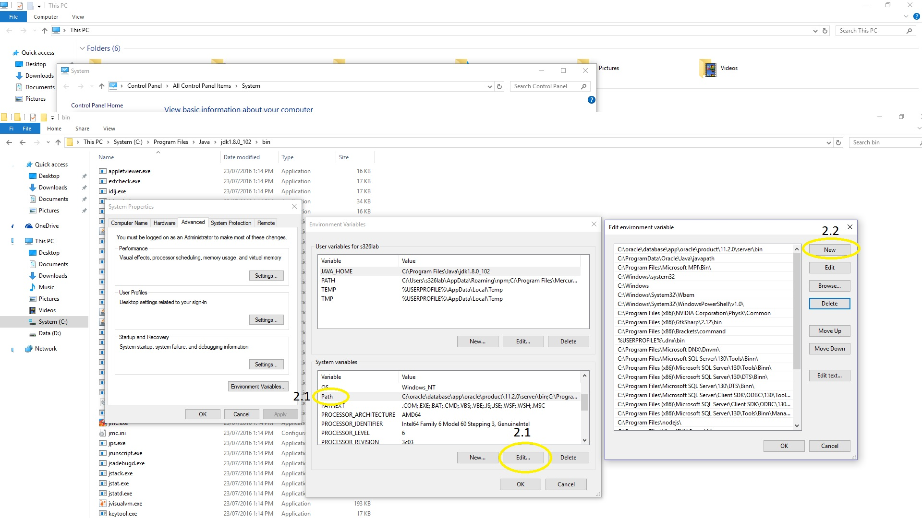

2.3 Paste the directory you have copied in step 2.0

2.4 Click OK

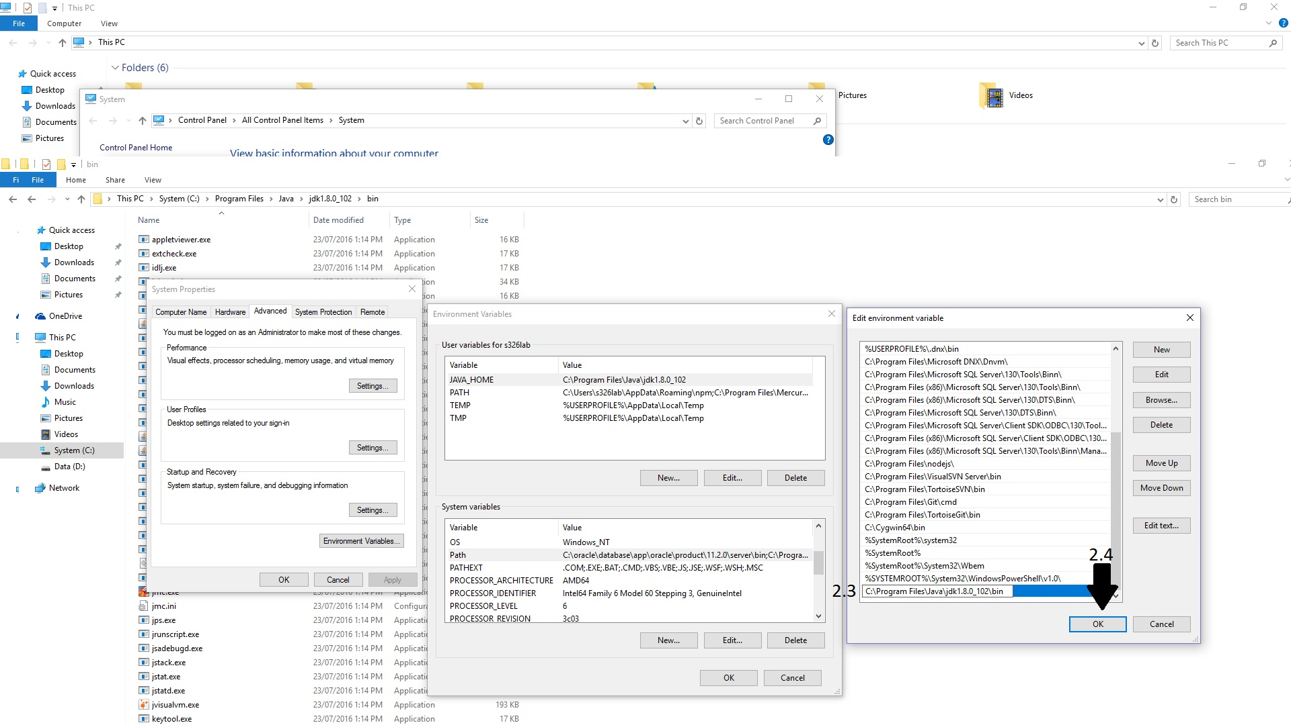

B. Setting up Maven Environment Variables

1.0 Extract Maven to a directory and copy the location

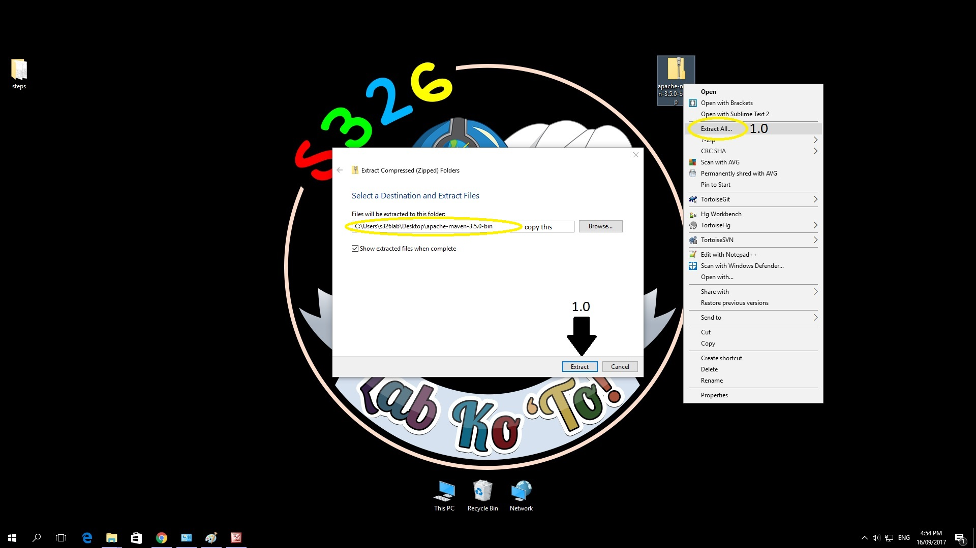

1.1 Go to my computer; check the system properties by doing a right click and select properties

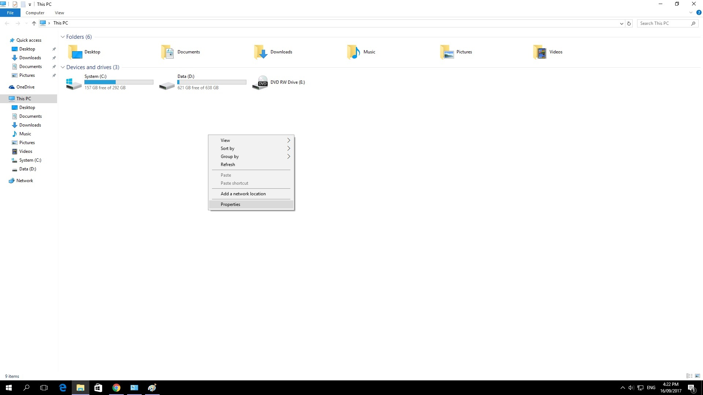

1.2 Open Advanced system settings



1.3 Open Environment Variables



1.4 Go to User Variables, click New…

1.5 For variable name, put MAVEN_HOME  
1.6 For variable value, paste the directory you have copied in step 1.0

1.7 Click OK

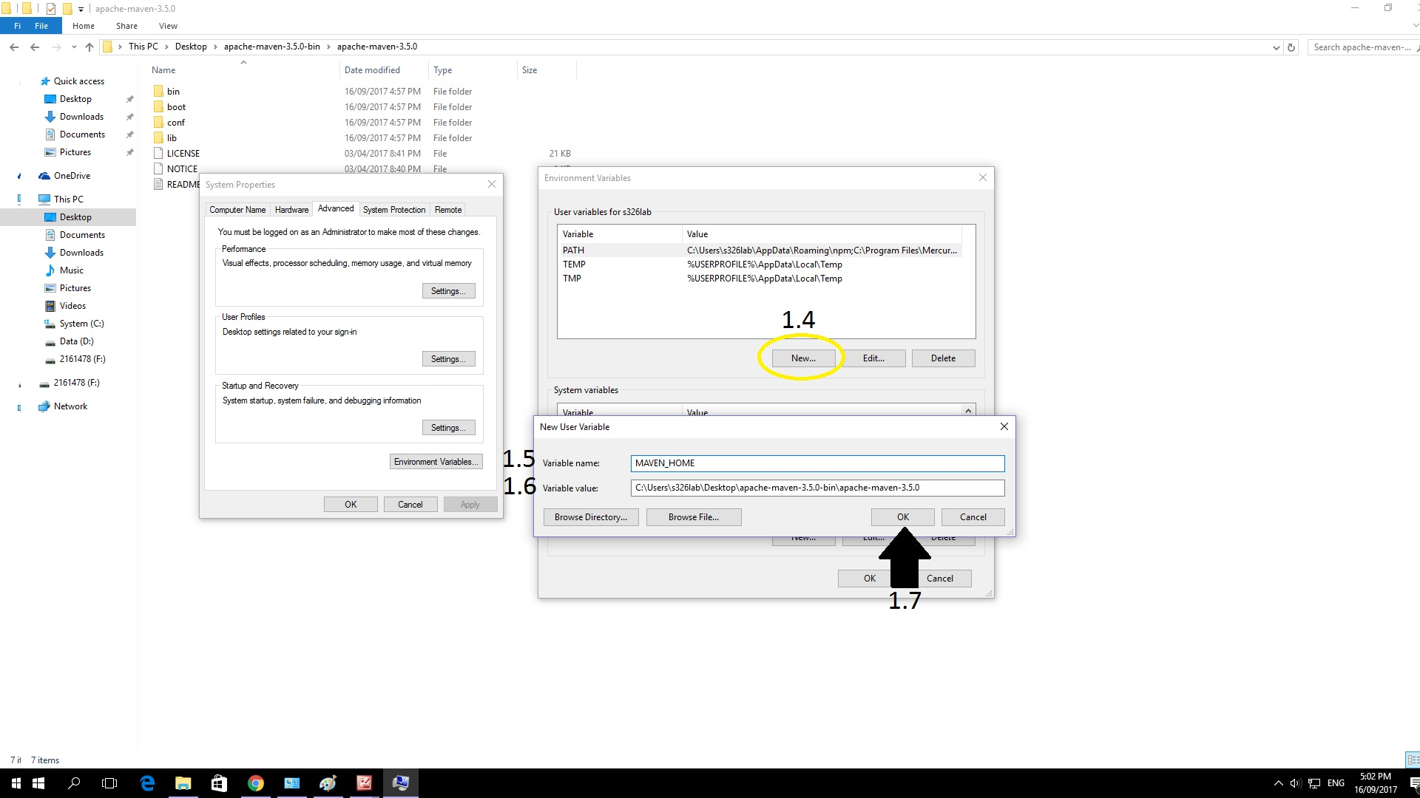

1.8 Create another User Variable, Click New…

1.9 For variable name, put M2_HOME

2.0 For variable value, paste the directory you have copied in step 1.0

2.1 Click OK

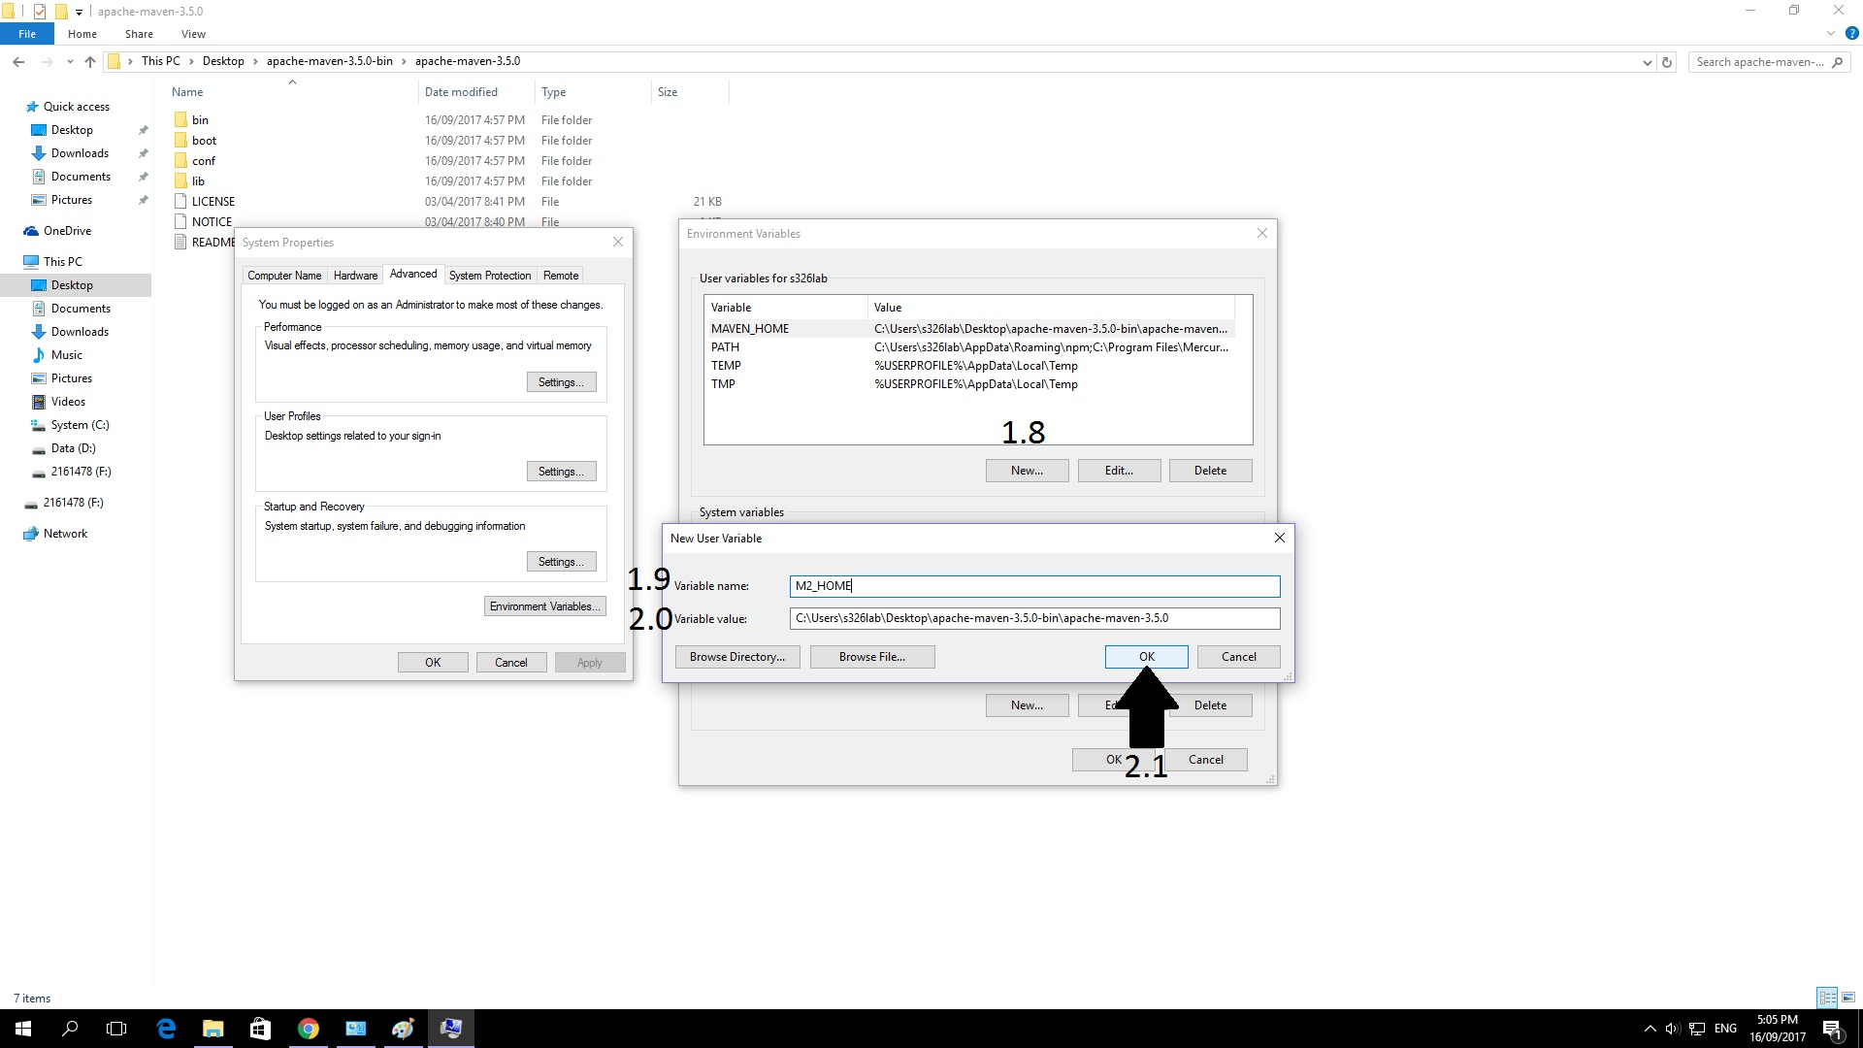

2.2 Locate your java Maven bin folder (e.g. C:\Users\Username\Desktop\apache-maven-3.5.0\bin) and copy its directory

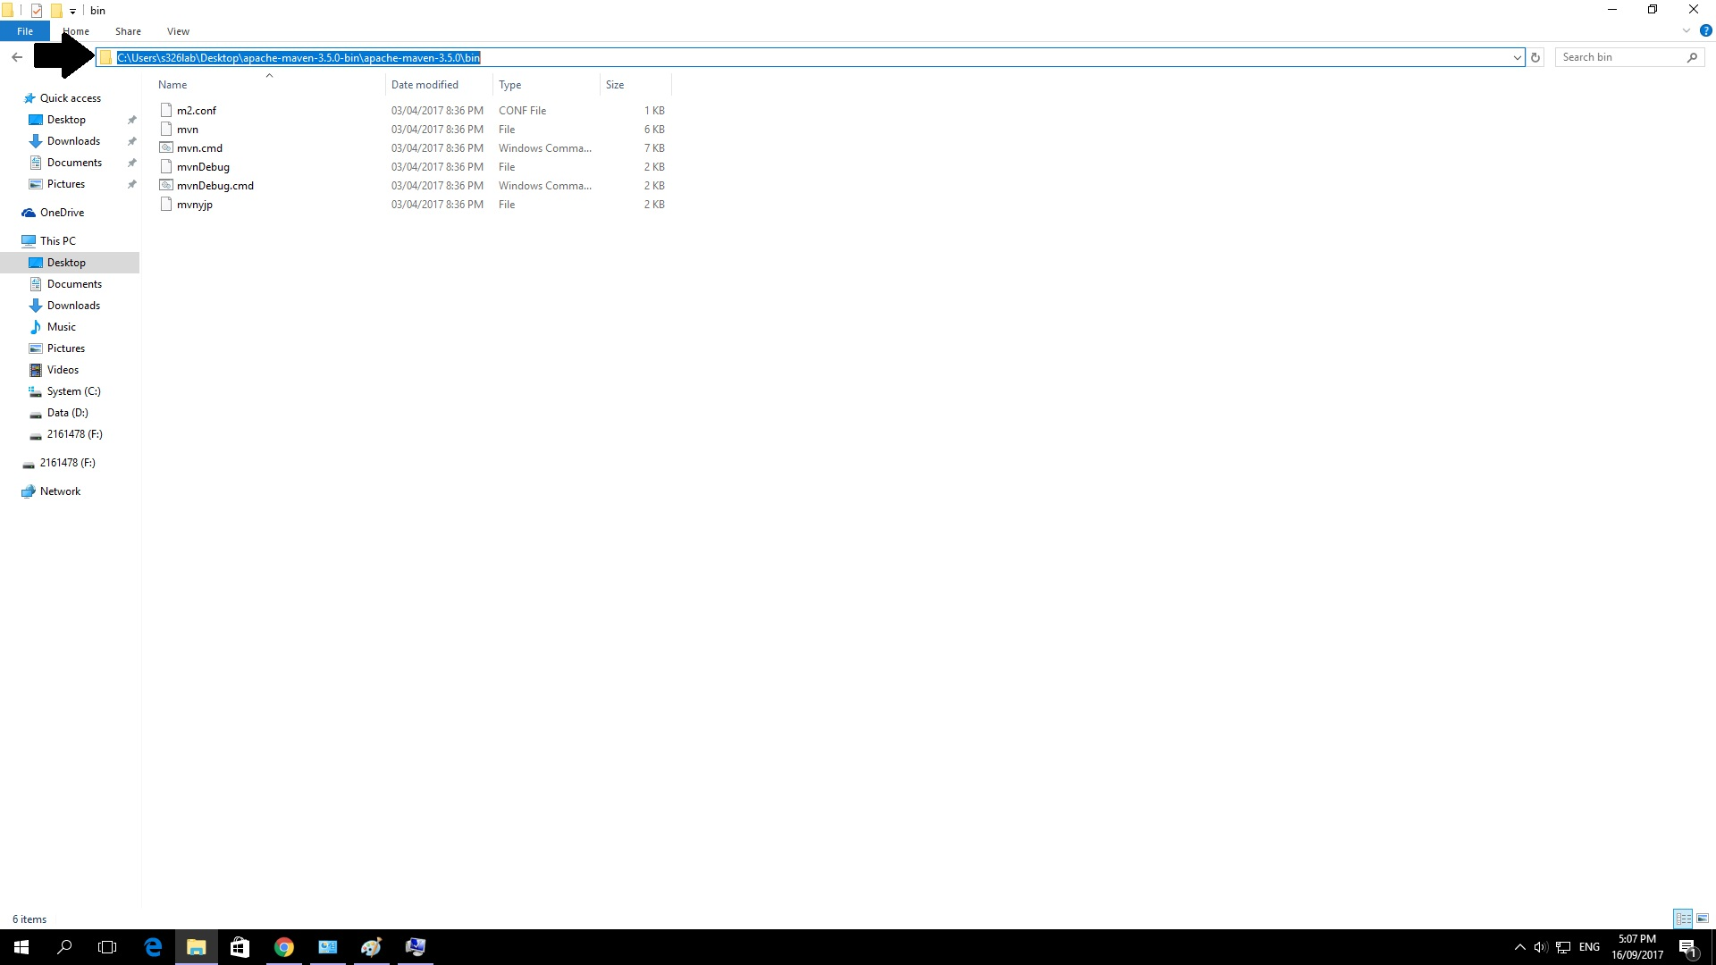

2.3 Go to System Variables locate “Path” click Edit

2.4 Click New

2.5 Paste the directory you have copied in step 2.2

2.6 Click OK

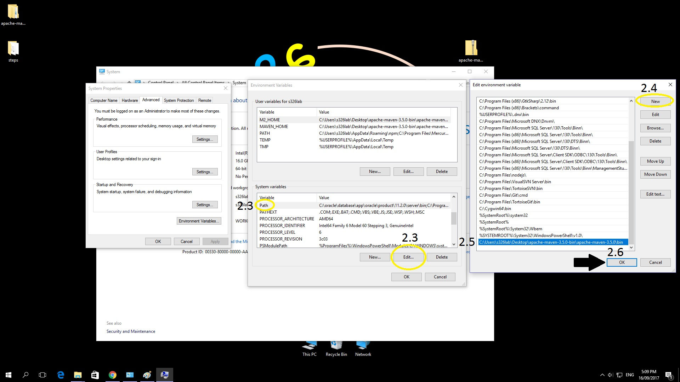

C. INSTALLATION VALIDATION

1.0 Click Start, open command prompt by typing “cmd”

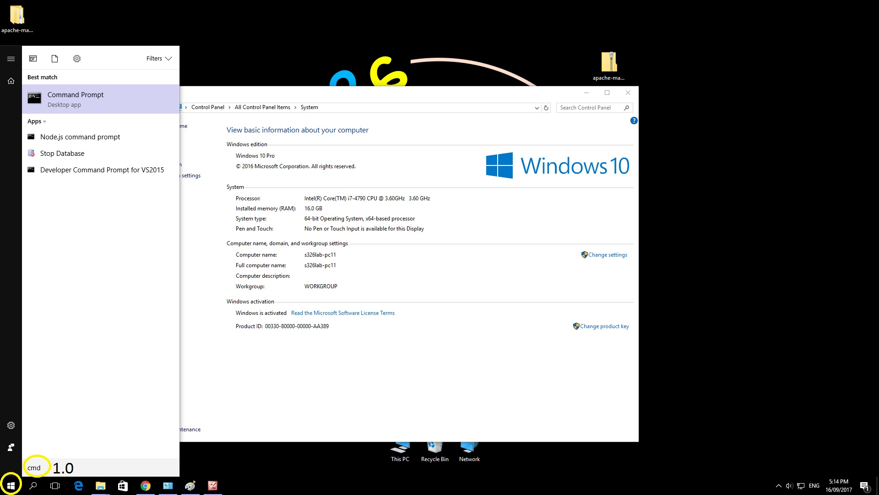

1.1 Type “mvn –version”, this command will return the version of maven and jdk you have installed. The command will also show you the location of Maven and Java Home.

